

Skype for Business is the only place you’ll need to be. With meetings always just one click away, you can present and take notes together, record all the details, and use HD video and in-meeting IM to communicate loud and clear.

This flyer is designed to be handed out during your Office 365 rollout. Make sure to customize the areas shown in orange below and print the flyer on 8 ½ x 11 paper. For added emphasis, you can laminate the flyer after printing.

!

Run more effective meetings

Macintosh HD:Users:speaslee:Desktop:concept1.png

Learn what you can do with Office 365

Training Visit the Office 365 Learning Center at aka.ms/o365learning. <If available, add links to your organization’s internal training resources.>

Events <Tell people about your upcoming Office 365 events. For example, “Join our weekly lunch and learn every Monday at noon in the cafeteria.”>

Community <Add links to your Office 365 communities or Yammer groups.>

!

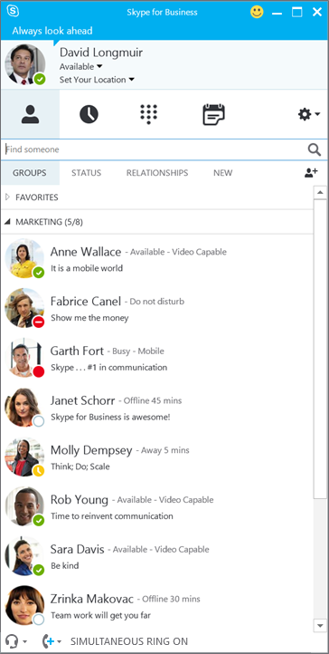

Meet now If you have a subject that requires immediate attention, quickly start an impromptu meeting. From the **Tool** icon, select   
**Meet Now** and add participants. From there, you can share your screen, a program, or a file.

Use video in meetings   
Enhance your meeting experience and keep people engaged by adding video to your Skype for Business Meeting. Remember to set up and test your camera before the meeting to make sure it’s all ready. From within the meeting, select the **Video** icon then   
**Start My Video**.

Join a meeting from your mobile device If you're on the go and need to join a meeting, simply open the Lync app on your mobile device. Select **Meetings**, find the meeting you want to join and select **Join Meeting**. You'll get audio and video along with all the shared content.

Share your screen   
As a presenter, you can share a program, a whiteboard, or your desktop so everyone is on the same page. Within the meeting, select the **Screen** icon then choose what you would like to present to the group.

Visit [www.office.microsoft.com/mobile](http://www.office.microsoft.com/mobile) to set up Office 365 on your devices.

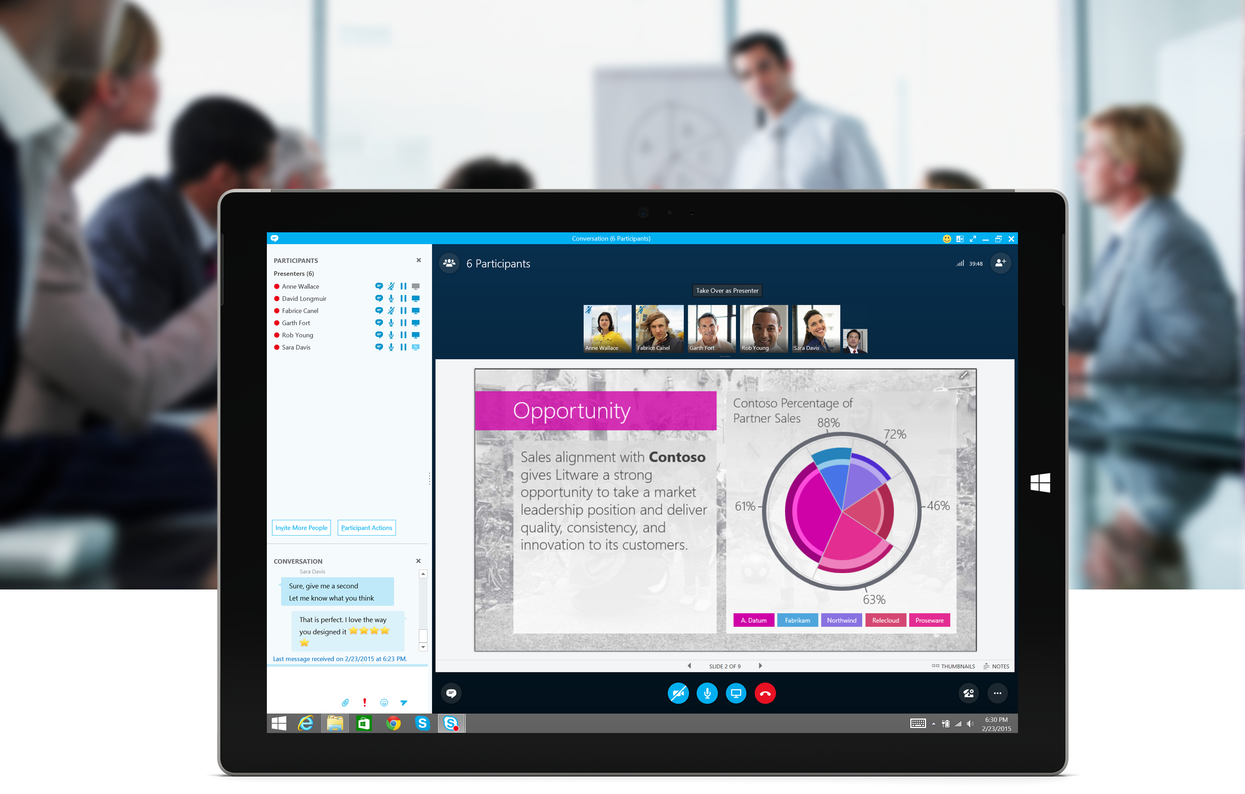

Take notes in a meeting

Use video in meetings

Invite more people

Share your screen or present content

Share your thoughts in IM

Record your meeting